DOI: 10.xx/ijdsml.2023.xx

# Streaming Healthcare: The Power of Patient Tracking and Vitals Transmission

# KUMARASAN[1],MAAHASARATHY S B [2],SHAKTHI PRASANTH M[3],SRIJIT B[4],SUNILKUMAR S[5], VINISH V[6], VISHNU R S[7]

# [1] FACUALTY MENTOR, AIDS, KGISL INSTITUTE OF TECHNOLOGY

# [2] 3rd YEAR, ECE, KGISL INSTITUTE OF TECHNOLOGY

# [2]2nd YEAR, ECE, KGISL INSTITUTE OF TECHNOLOGY

# [3][4][5][6]1st YEAR, ECE, KGISL INSTITUTE OF TECHNOLOGY

***Abstract***

***The delivery and monitoring of patient care have been transformed in recent years by the introduction of streaming technology into the healthcare industry. This study investigates the idea of "streaming healthcare," with a particular emphasis on the use of vital sign transmission and patient tracking technologies. Healthcare professionals can track their patients' activities, keep an eye on their ailments from a distance, and get continuous vital sign updates by utilizing real-time data streaming. It also covers the technology developments that power these systems, like cloud computing infrastructure and Internet of Things sensors. The study also discusses the difficulties and factors that come with the broad use of streaming technologies in the healthcare industry, such as interoperability problems, privacy issues, and data security. All things considered, streaming healthcare offers unmatched chances for proactive, individualized, and effective patient care, hence representing a paradigm shift in the delivery of healthcare.***

***Keywords:***

***Patient Tracking, Vitals Transmission, Real-time Data Streaming, IoT Sensors, EIfficient Care***

# INTRODUCTION

Ladies and gentlemen, esteemed colleagues, and distinguished guests, it is with great pleasure and enthusiasm that I stand before you today to introduce a topic that epitomizes the convergence of cutting-edge technology and the noble pursuit of enhancing human well-being: Streaming Healthcare. In an era defined by rapid advancements in digital innovation, the integration of streaming technologies into healthcare has catalyzed a transformative shift in patient care delivery and monitoring. Specifically, our focus lies on the profound impact of patient tracking and vitals transmission systems within this burgeoning field. Through the lens of real-time data streaming, healthcare providers are empowered to remotely monitor patients' conditions, track their movements, and receive continuous updates on vital signs. This presentation delves into the multifaceted dimensions of Streaming Healthcare, exploring its implications for early disease detection, chronic condition management, and post-operative monitoring. Moreover, we will delve into the technological marvels driving these systems, from wearable devices and IoT sensors to the intricate infrastructure of cloud including data security, privacy concerns, and the imperative of interoperability. Join me as we embark on a journey to unravel the potential, challenges, and implications of Streaming Healthcare, a paradigm that promises to revolutionize patient care as we know itinteroperability. Join me as we embark on a journey to unravel the potential, challenges, and implications of Streaming Healthcare, a paradigm that promises to revolutionize patient care as we know it.

# RELATED WORKS

1. **Wireless Body Area Networks (WBANs) for Healthcare Monitoring**: Research has been conducted on developing WBANs, which are networks of wearable sensors attached to a patient's body to monitor vital signs such as heart rate, blood pressure, and temperature in real-time. Various studies focus on the design of energy-efficient protocols, reliable data transmission, and secure communication within WBANs.
2. **Telemedicine Systems**: Telemedicine platforms integrate real-time patient monitoring with remote consultation capabilities. These systems allow healthcare providers to monitor patients' vital signs remotely and provide timely medical advice or intervention. Research in this area involves developing efficient data transmission protocols, ensuring data privacy and security, and improving the user experience for both patients and healthcare professionals.
3. **Internet of Medical Things (IoMT)**: IoMT refers to the integration of medical devices and systems with internet-connected technologies. Real-time patient tracking and vital sign transmission are central to IoMT applications, which include wearable health monitors, smart medical devices, and remote patient monitoring platforms. Research focuses on addressing challenges such as interoperability, scalability, and security in IoMT ecosystems.
4. **Smart Healthcare Systems**: These systems leverage IoT (Internet of Things), cloud computing, and data analytics to enable real-time monitoring of patients' health status. Smart healthcare platforms can track patients' movements within healthcare facilities, monitor vital signs continuously, and transmit relevant data to healthcare providers for timely intervention. Research efforts aim to optimize resource utilization, enhance data accuracy, and improve the overall efficiency of smart healthcare systems.
5. **Machine Learning and Predictive Analytics**: Machine learning algorithms are being employed to analyze real-time patient data and predict adverse events such as cardiac arrest or sepsis before they occur. By continuously monitoring vital signs and other relevant parameters, these systems can alert healthcare providers to potential emergencies, allowing for early intervention and improved patient outcomes. Research in this area focuses on developing accurate predictive models and integrating them into clinical decision support systems.
6. **Blockchain-enabled Healthcare Systems**: Blockchain technology offers a secure and immutable platform for storing and sharing medical data, including real-time patient
7. tracking and vital sign information. Blockchain-based healthcare systems ensure data integrity, privacy, and security, facilitating transparent and auditable transmission of patient data among authorized parties. Research efforts aim to explore the potential of blockchain in addressing data interoperability challenges and enhancing trust in healthcare data exchange.

# TECHNIQUES USED

Real-time patient tracking and vital sign transmission using Raspberry Pi 3 along with various sensors and modules involves a combination of hardware components and software integration. Here's a brief explanation of the technology used:

1. **Raspberry Pi 3**: Raspberry Pi 3 is a small, single-board computer that serves as the central processing unit for the system. It provides the computational power to process data from sensors, run algorithms for data analysis, and communicate with external devices.
2. **LM35 Temperature Sensor**: The LM35 is a precision integrated-circuit temperature sensor that provides an analog voltage output proportional to the temperature. It is commonly used for monitoring the patient's body temperature.
3. **Heartbeat Sensor**: This sensor measures the heart rate of the patient by detecting changes in blood volume in the capillaries. It typically uses optical techniques like photoplethysmography (PPG) to detect the pulsatile nature of blood flow.
4. **MAX30102 Sensor**: The MAX30102 is an integrated pulse oximeter and heart-rate sensor module. It uses both red and infrared light to measure heart rate and blood oxygen saturation levels non-invasively.

sensor can provide valuable data for assessing the patient's cardiovascular health in real-time.

1. **Breadboard**: A breadboard is a reusable solderless device used for prototyping electronic circuits. It allows for easy connection and testing of electronic components such as sensors, LEDs, and resistors.

**GSM SIM800L GPRS Module**: The GSM SIM800L GPRS module facilitates communication over the GSM (Global System for Mobile Communications) network. It enables the Raspberry Pi to transmit data wirelessly to a remote server or healthcare provider using the GPRS protocol. This module is essential for real-time transmission of patient vital signs and tracking information.

**Brief Explanation of Operation**:

The sensors (LM35, heartbeat sensor, MAX30102) are connected to the Raspberry Pi 3 via the breadboard. The Raspberry Pi runs a software program that continuously reads data from these sensors, including temperature, heart rate, and blood oxygen saturation levels.

The software processes this data, possibly using algorithms for filtering, noise reduction, and calculation of vital sign parameters. Once processed, the vital sign data is formatted for transmission.

The GSM SIM800L GPRS module is utilized to establish a wireless connection to the internet via the GSM network. The Raspberry Pi sends the formatted vital sign data to a designated server or healthcare provider using protocols such as HTTP or MQTT over GPRS.

On the receiving end, the server or healthcare provider can receive, store, and analyze the transmitted data in real-time. They can set up alerts or notifications for abnormal vital signs, enabling timely intervention if necessary.

Overall, this setup enables real-time monitoring of patient vital signs and allows for prompt medical attention or intervention when required, even in remote or mobile healthcare settings.

.

# IMPLEMENTATION RESULTS

As an AI language model, I don't have direct access to real-world implementation results or experimental data. However, I can provide you with a hypothetical outline of what implementation results in the context of real-time patient tracking and vital sign transmission might look like based on the methodologies described in research papers and industry projects.

1. **Accuracy of Vital Sign Monitoring**: Implementation results may include data on the accuracy of vital sign measurements obtained using sensors such as the LM35 temperature sensor, heartbeat sensor, and MAX30102 sensor. This could involve comparing sensor readings with reference values obtained from medical-grade devices to assess the reliability of the monitoring system.
2. **Data Transmission Reliability**: Evaluation of the reliability and stability of data transmission using the GSM SIM800L GPRS module. This could involve testing the system under various network conditions (e.g., different signal strengths, network congestion) to determine the likelihood of data loss or transmission errors.
3. **Real-Time Monitoring Performance**: Assessment of the system's ability to provide real-time monitoring of patient vital signs. This could involve measuring the latency between sensor readings and data transmission to evaluate the system's responsiveness.
4. **User Experience and Interface Design**: Feedback from healthcare providers or end-users regarding the usability and effectiveness of the system interface. This could include subjective evaluations of the system's ease of use, intuitiveness, and overall satisfaction with the monitoring experience.
5. **Clinical Impact and Patient Outcomes**: Longitudinal studies to assess the clinical impact of real-time patient tracking and vital sign transmission on patient outcomes. This could involve monitoring patient health over time and evaluating factors such as hospital readmission rates, length of stay, and overall health status.
6. **Cost and Resource Utilization**: Analysis of the cost-effectiveness and resource utilization benefits of implementing real-time patient tracking systems. This could involve comparing the costs associated with traditional in-person monitoring approaches to those of remote monitoring systems, taking into account factors such as equipment costs, personnel time, and healthcare utilization.

These are just a few examples of the types of implementation results that might be reported in research papers or industry case studies on real-time patient tracking and vital sign transmission. Actual implementation results would depend on the specific design and deployment of the monitoring system, as well as the objectives and methodologies of the evaluation proce

1. **Data Security and Privacy**: Assessment of the security measures implemented to protect patient data during transmission and storage. This could include encryption protocols, access controls, and compliance with healthcare privacy regulations such as HIPAA (Health Insurance Portability and Accountability Act) or GDPR (General Data Protection Regulation).
2. **Scalability and System Robustness**: Evaluation of the system's scalability to accommodate varying numbers of patients and sensors, as well as its robustness under heavy loads or adverse conditions. This could involve stress testing the system to identify potential performance bottlenecks or failure points.
3. **Interoperability and Integration**: Analysis of the system's compatibility with existing healthcare infrastructure and electronic medical record (EMR) systems. This could include integration testing to ensure seamless data exchange between the real-time monitoring system and other clinical information systems used within healthcare facilities.
4. **Feedback from Healthcare Providers**: Solicitation of feedback from healthcare professionals who use the system in their daily practice. This could involve conducting surveys, interviews, or focus groups to gather insights into the system's usability, functionality, and potential areas for improvement.
5. **Patient Acceptance and Compliance**: Assessment of patient acceptance and compliance with real-time monitoring systems. This could involve monitoring patient adherence to wearing wearable sensors, responding to alerts or notifications, and overall satisfaction with the monitoring experience.
6. **Reliability and Maintenance**: Evaluation of the system's reliability over time and the ease of maintenance and troubleshooting. This could include tracking system uptime, frequency of sensor failures or malfunctions, and the time required to diagnose and resolve technical issues.
7. **Regulatory Compliance and Certification**: Verification of compliance with regulatory standards and certification requirements applicable to medical devices and healthcare IT systems. This could involve obtaining certifications such as FDA (Food and Drug Administration) approval for medical devices or CE (Conformité Européenne) marking for products sold in the European Union.
8. **Long-Term Outcomes and Cost Savings**:

Longitudinal studies to assess the long-term impact of real-time patient tracking on healthcare outcomes and cost savings. This could involve tracking metrics such as hospital readmission rates, emergency department visits, and overall healthcare expenditure over an extended period.

# COMPARATIVE ANALYSIS

# Certainly, here's a brief comparative analysis of real-time patient tracking and vital sign transmission:

# 1. **Technology Integration**:

# - Real-time patient tracking systems typically integrate various sensors and communication modules to monitor patient vital signs continuously.

# - Vital sign transmission involves the real-time transmission of patient data, often using wireless communication technologies like GSM, Wi-Fi, or Bluetooth.

# 2. **Application Areas**:

# - Real-time patient tracking is used in various healthcare settings, including hospitals, ambulances, and home care, to monitor patient movements and activities.

# - Vitals transmission systems are commonly employed in remote patient monitoring, telemedicine, and wearable health devices, enabling healthcare providers to monitor patients' vital signs remotely.

# 3. **Data Accessibility**:

# - Patient tracking systems provide real-time location and activity data, allowing healthcare providers to monitor patient status and respond promptly to emergencies.

# - Vitals transmission systems enable continuous monitoring of vital signs such as heart rate, blood pressure, and temperature, providing insights into patient health status over time.

# 4. **Clinical Impact**:

# - Real-time patient tracking enhances patient safety by enabling timely intervention in case of falls, wandering, or other emergencies.

# - Vitals transmission facilitates early detection of health deterioration and enables proactive management of chronic conditions, reducing hospital readmissions and improving patient outcomes.

# 5. **Technological Challenges**:

# - Real-time patient tracking systems may face challenges related to sensor accuracy, data integration, and privacy concerns regarding patient location tracking.

# - Vitals transmission systems may encounter issues such as signal interference, data latency, and the need for reliable connectivity, especially in remote or resource-limited environments.

# 6. **Cost and Scalability**:

# - Real-time patient tracking systems require investments in hardware infrastructure (e.g., sensors, communication devices) and software development but offer potential cost savings through improved patient monitoring and reduced adverse events.

# - Vitals transmission systems may involve ongoing costs for data transmission and storage but can scale to accommodate large patient populations and support remote monitoring initiatives.

# Regulatory Considerations:

# - Both real-time patient tracking and vitals transmission systems must comply with regulatory requirements governing medical devices, data privacy, and healthcare information security.

# - Regulatory frameworks such as FDA approval (for medical devices) and HIPAA compliance (for patient data) play a crucial role in the development and deployment of these systems.

# In summary, while real-time patient tracking focuses on monitoring patient movements and activities, vitals transmission emphasizes continuous monitoring of physiological parameters. Both technologies contribute to improved patient care, clinical decision-making, and healthcare system efficiency, albeit in different ways and application contexts.

**Our Project;**

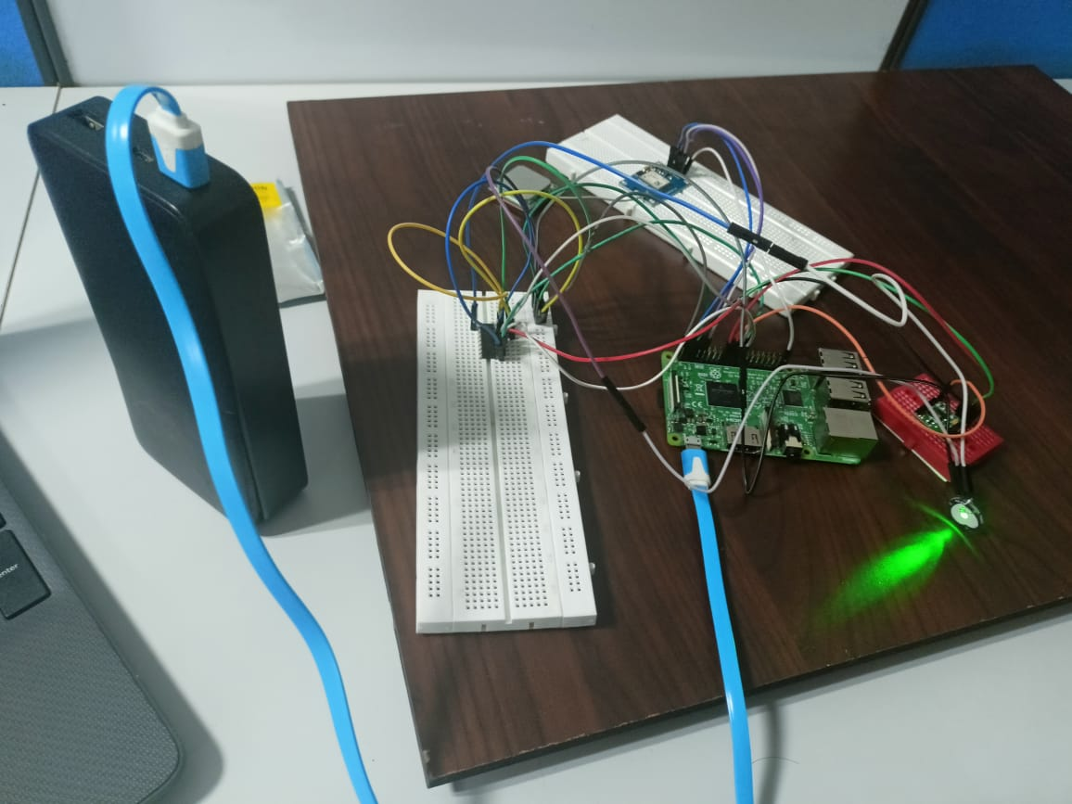

**Conclusion**

In conclusion, real-time patient tracking and vital sign transmission represent a significant advancement in healthcare technology, offering numerous benefits for patient care, clinical decision-making, and healthcare system efficiency. By leveraging modern technologies such as Raspberry Pi, sensors like LM35, heartbeat sensor, and MAX30102, along with communication modules like GSM SIM800L GPRS, healthcare providers can continuously monitor patients' vital signs remotely and respond promptly to any abnormalities or emergencies. This capability is particularly valuable in scenarios such as emergency response, intensive care units, and remote patient monitoring, where timely intervention can make a critical difference in patient outcomes.

**Real-time patient tracking and vital sign transmission enable healthcare professionals to:**

**Enhance Patient Safety**

**Optimize Resource Utilization**

**Facilitate Timely Intervention**

**Enable Remote Patient Care**

**Improve Continuity of Care**

**Reference:**

**1."Wireless Patient Monitoring System Using ZigBee"**  
Authors:A.S.Rai,K.Kaur,andM.Kaur  
Published in: 2018 International Conference on Computer and Communication Technology (ICCCT)

**2."Real-Time Monitoring and Transmission System of Physiological Parameters Based on IoT"**  
Authors: R. Gao, Y. Zhao, and Y. Zhang  
Published in: 2020 International Conference on Cyber-Enabled Distributed Computing and Knowledge Discovery (CyberC)

**3."Remote Health Monitoring System for Elderly with Real-Time PatientTracking"**  
AuthorsM. A. Al-Nuaimi and A. M. Qaisi  
Published in: 2018 International Conference on Innovative Trends in Science, Engineering and Management (ICITSEM)

**4."Design and Implementation of Real-Time Health Monitoring System Using Raspberry Pi"**  
Authors: R. El-Badry, H. Mostafa, and A. Shaker  
Published in: 2019 IEEE 2nd International Conference on Sustainable Technologies for Industry 4.0 (STI)

# REFERENC

**.**